HYDRALOOP TRAINING

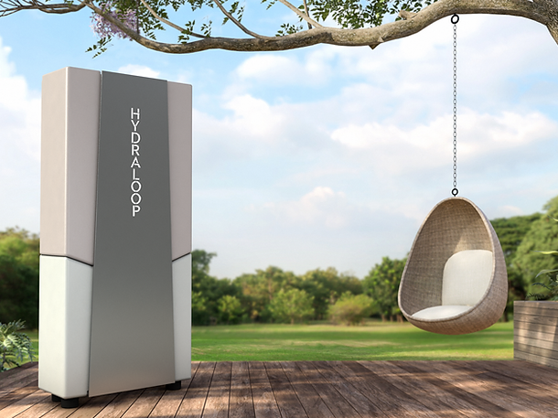

Please join us for a two hour training in the Hydraloop system.
Marc Rico, with Hydraloop will be leading the seminar.
Hydraloop is a sustainable in-house water treatment appliance that produces NSF 350 compliant greywater for toilet flushing.
The training will take place June 27th from 2 to 4 pm in Thomas Auditorium at Coconino County Community Development at 2500 N Fort Valley Rd, Flagstaff, AZ.
Please RSVP to Steve White, Lead Plans Examiner, Coconino County Building Division if you plan to attend: swhite@coconino.az.gov.
Hope to see you there

